Mathematical Corollary

🌟 Definition
# Source: AI Source: Provided by: [Data Path: Persons Table -> ID Column: 1, Name_En Column: Motasem Essam] -> From: [ChatGPT] on [5/29/2026]
A mathematical corollary is a statement that follows directly and easily from a previously proven theorem or proposition, without needing much additional proof.
It is a simple consequence of a theorem.

🎯 Purpose of a Corollary
# Source: AI Source: Provided by: [Data Path: Persons Table -> ID Column: 1, Name_En Column: Motasem Essam] -> From: [ChatGPT] on [5/29/2026]
- To highlight useful results that come from a theorem
- To simplify the application of a theorem
- To show important special cases
- To extend the meaning of a theorem
- To organize mathematical results clearly

📚 Key Characteristics
# Source: AI Source: Provided by: [Data Path: Persons Table -> ID Column: 1, Name_En Column: Motasem Essam] -> From: [ChatGPT] on [5/29/2026]
A corollary is:
- Derived from a theorem or proposition
- Proven with minimal or no extra work
- A direct consequence of a known result
- Often simpler than the main theorem
- Useful in applications and problem-solving

🧩 Structure of a Corollary
# Source: AI Source: Provided by: [Data Path: Persons Table -> ID Column: 1, Name_En Column: Motasem Essam] -> From: [ChatGPT] on [5/29/2026]
- A theorem or major result
- A logical consequence of that theorem
- A short proof (if needed)

✏️ Examples of Corollaries

Example 1 (From Geometry)
# Source: AI Source: Provided by: [Data Path: Persons Table -> ID Column: 1, Name_En Column: Motasem Essam] -> From: [ChatGPT] on [5/29/2026]
Theorem:
The angles of a triangle sum to 180°.
Corollary:
All angles in an equilateral triangle are 60°.

Example 2 (From Number Theory)
# Source: AI Source: Provided by: [Data Path: Persons Table -> ID Column: 1, Name_En Column: Motasem Essam] -> From: [ChatGPT] on [5/29/2026]
Theorem:
There are infinitely many prime numbers.
Corollary:
There is no largest prime number.

Example 3 (From Algebra)
# Source: AI Source: Provided by: [Data Path: Persons Table -> ID Column: 1, Name_En Column: Motasem Essam] -> From: [ChatGPT] on [5/29/2026]
Theorem:
If a × b = 0, then a = 0 or b = 0.
Corollary:
If neither a nor b is zero, then their product is not zero.

Example 4 (Symbolic Example)
# Source: AI Source: Provided by: [Data Path: Persons Table -> ID Column: 1, Name_En Column: Motasem Essam] -> From: [ChatGPT] on [5/29/2026]
From the theorem:
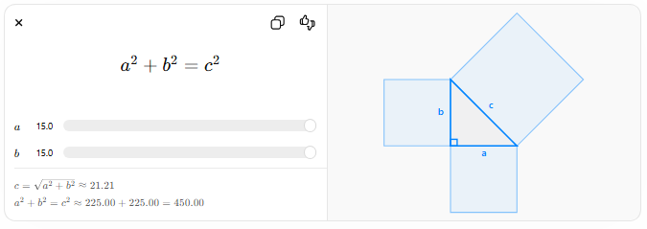
$$a^{2}+b^{2}=c^{2}$$
$$a$$
$$b$$
$$c=\sqrt{a^{2}+b^{2}}≈21.21$$
$$a^{2}+b^{2}=c^{2}≈225.00+225.00=450.00$$
A corollary might be:
If $a=b$, then:
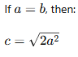
$$c=\sqrt{2a^{2}}$$

🔗 Relationship to Other Concepts
# Source: AI Source: Provided by: [Data Path: Persons Table -> ID Column: 1, Name_En Column: Motasem Essam] -> From: [ChatGPT] on [5/29/2026]
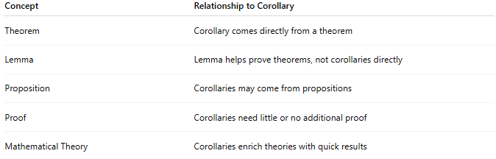
Concept | Relationship to Corollary
Theorem | Corollary comes directly from a theorem
Lemma | Lemma helps prove theorems, not corollaries directly
Proposition | Corollaries may come from propositions
Proof | Corollaries need little or no additional proof
Mathematical Theory | Corollaries enrich theories with quick results

📖 Corollary vs Theorem vs Lemma
# Source: AI Source: Provided by: [Data Path: Persons Table -> ID Column: 1, Name_En Column: Motasem Essam] -> From: [ChatGPT] on [5/29/2026]
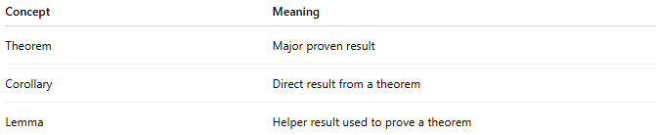
Concept | Meaning
Theorem | Major proven result
Corollary | Direct result from a theorem
Lemma | Helper result used to prove a theorem

🧠 Simple Analogy
# Source: AI Source: Provided by: [Data Path: Persons Table -> ID Column: 1, Name_En Column: Motasem Essam] -> From: [ChatGPT] on [5/29/2026]
A corollary is like a bonus result:
- The theorem is the main discovery
- The corollary is an easy consequence that comes for free

🧭 Summary
# Source: AI Source: Provided by: [Data Path: Persons Table -> ID Column: 1, Name_En Column: Motasem Essam] -> From: [ChatGPT] on [5/29/2026]
A mathematical corollary is a statement that follows directly from a theorem. It usually requires little or no extra proof and highlights useful consequences of an already proven result.

